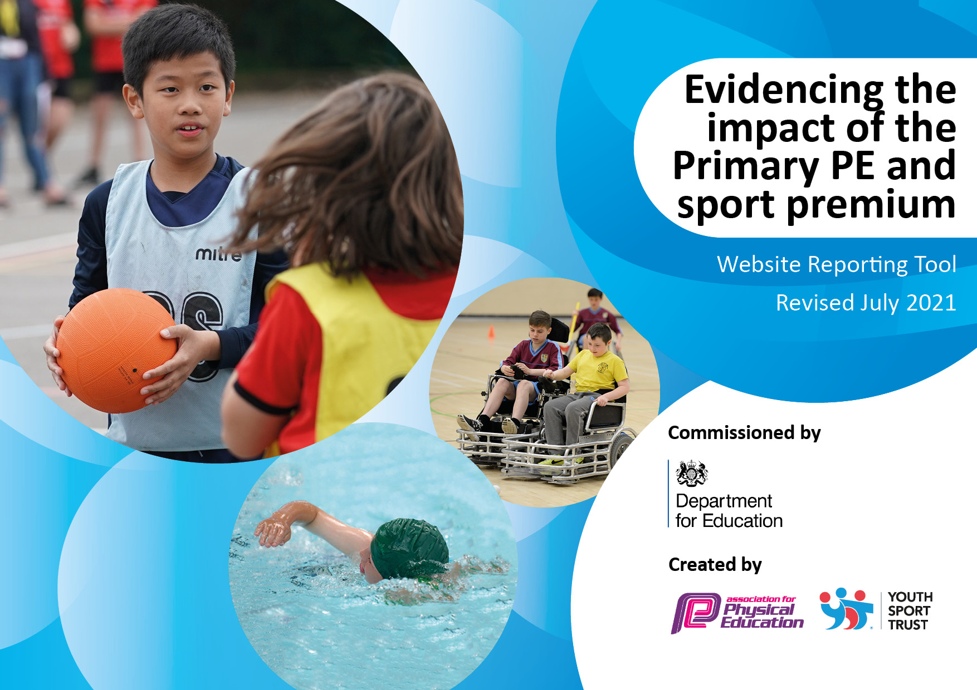
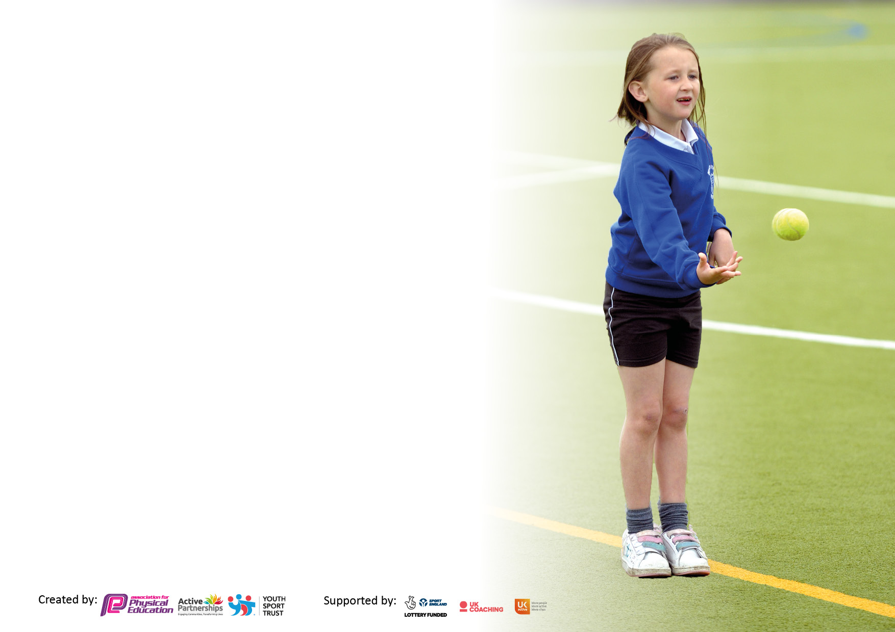

It is important that your grant is used effectively and based on school need. The Education Inspection Framework makes clear there will be a focus on ‘whether leaders and those responsible for governors all understand their respective roles and perform these in a way that enhances the effectiveness of the school’.

Under the Quality of Education Ofsted inspectors consider:
Intent - Curriculum design, coverage and appropriateness
Implementation - Curriculum delivery, Teaching (pedagogy) and Assessment
Impact - Attainment and progress

To assist schools with common transferable language this template has been developed to utilise the same three headings which should make your plans easily transferable between working documents.

Schools must use the funding to make additional and sustainable improvements to the quality of Physical Education, School Sport and Physical Activity (PESSPA) they offer. This means that you should use the Primary PE and sport premium to:

- Develop or add to the PESSPA activities that your school already offer
- Build capacity and capability within the school to ensure that improvements made now will benefit pupils joining the school in future years
- The Primary PE and sport premium should not be used to fund capital spend projects; the school’s budget should fund these.

Pleasevisitgov.ukfortherevisedDfEguidanceincludingthe5keyindicatorsacrosswhichschoolsshoulddemonstrate an improvement. This document will help you to review your provision and to report your spend. DfE encourages schools to use this template as an effective way of meeting the reporting requirements of the Primary PE and sport premium.

We recommend you start by reflecting on the impact of current provision and reviewing the previous spend.

Schools are required to publish details of how they spend this funding, including any under-spend from 2019/2020, as well as on the impact it has on pupils’ PE and sport participation and attainment. All funding must be spent by 31st July 2022.

We recommend regularly updating the table and publishing it on your website throughout the year. This evidences your ongoing self-evaluation of how you are using the funding to secure maximum, sustainable impact. Final copy must be posted on your website by the end of the academic year and no later than the 31st July 2021. To see an example of how to complete the table please click HERE.
Created by: Supported by:

Details with regard to funding
Please complete the table below.

Total amount carried over from 2019/20 | £13,505.15
Total amount allocated for 2020/21 | £19,535
How much (if any) do you intend to carry over from this total fund into 2021/22? | £25,715.83
Total amount allocated for 2021/22 | £19,520
Total amount of funding for 2021/22. To be spent and reported on by 31st July 2022. | £45,235.83
Swimming Data
Please report on your Swimming Data below.

Meeting national curriculum requirements for swimming and water safety.  N.B. Complete this section to your best ability. For example, you might have practised safe self-rescue techniques on dry land which you can then transfer to the pool when school swimming restarts.  Due to exceptional circumstances priority should be given to ensuring that pupils can perform safe self-rescue even if they do not fully meet the first two requirements of the NC programme of study | Swimming results below for current year 6 July 2022
What percentage of your current Year 6 cohort swim competently, confidently and proficiently over a distance of at least 25 metres?  N.B. Even though your pupils may swim in another year please report on their attainment on leaving primary school at the end of the summer term 2021.  Please see note above | 32%
What percentage of your current Year 6 cohort use a range of strokes effectively [for example, front crawl, backstroke and breaststroke]?  Please see note above | 99%
What percentage of your current Year 6 cohort perform safe self-rescue in different water-based situations? | 95%
Schools can choose to use the Primary PE and sport premium to provide additional provision for swimming but this must be for activity over and above the national curriculum requirements. Have you used it in this way? | No  Swimming lessons in Sept 2022 to Dec 2022 for year 4

Action Plan and Budget Tracking
Capture your intended annual spend against the 5 key indicators. Clarify the success criteria and evidence of impact that you intend to measure to evaluate for pupils today and for the future.

Academic Year: 2021/22 | Total fund allocated: £19,520 | Date Updated: July 2022
Key indicator 1: The engagement of all pupils in regular physical activity – Chief Medical Officers guidelines recommend that primary school pupils undertake at least 30 minutes of physical activity a day in school |  |  |  | Percentage of total allocation:
 |  |  |  | %
Intent | Implementation |  | Impact
Your school focus should be clear what you want the pupils to know and be able to do and about  what they need to learn and to  consolidate through practice: | Make sure your actions to achieve are linked to your intentions: | Funding allocated: | Evidence of impact: what do pupils now know and what can they now do? What has changed? | Sustainability and suggested next steps:
To improve and structure playtime provision  To improve and enhance equipment for after school clubs | Ordering of new equipment:  Year ½ bag, year ¾ bag. year 5/6 bag- Each to include 1 x football, 1 x basketball and 10 skipping ropes  Sports coaches /PE apprentice to provide playtime activities:  JM/LJ-Mon  LJ-Tues/Wed/Fri  SC-Thurs  DR Foundation Jan 2022 playground leader training  New order placed for football, tag rugby and dance equipment | £176.74  £400  Total: £576.74 | Children building on basic skills using this equipment at playtimes.  Children more focused/greater engagement on physical activities.  Behaviour at playtimes improved as children are more occupied.  Clubs provide children with wider opportunities and enable them to take the sport further. Some children from these are accessing clubs in their specialist area, basketball being one of these. Many children playing to a high standard in their chosen sport | Revised daily mile timetable for Sept 2022.  Re allocate equipment for playtimes Sept 2022  New equipment given to clubs to start Sept 2022
Key indicator 2: The profile of PESSPA being raised across the school as a tool for whole school improvement |  |  |  | Percentage of total allocation:
 |  |  |  | %
Intent | Implementation |  | Impact
Your school focus should be clear what you want the pupils to know and be able to do and about  what they need to learn and to  consolidate through practice: | Make sure your actions to achieve are linked to your intentions: | Funding allocated: | Evidence of impact: what do pupils now know and what can they now do? What has changed? | Sustainability and suggested next steps:
To support the improvement of physical development in our EYFS children through a wide choice of quality equipment to develop large and small motor skills including agility.  To employ a PE apprentice to support and enhance our PE provision in school. | Having assessed what FS need and spoken with the FS team an order has been placed -trikes, balance poles, climbing wall, obstacle course, basketballs and hoop.  Building of block paving roadway with wet pour ramp for cycling skills  In EYFS  PE apprentice LJ to start Sept 2021  Mentor-SR  Supporting lessons and some before and after school clubs.  Assisting with lunchtime activities  Supporting adult for competitions | £2146.32  £3,945  £5000  Total: £11,091.31 | Children now have improved opportunities to develop gross and fine motor skills. Balancing and agility skills improved.  Using the track to manoeuvre vehicles develops physical skills.  Targeted children have accessed basic skills groups on a lunchtime. This has developed their confidence and self-esteem.  Targeted children have had one to one support in lessons to give them further practise to master the skills. | Continue to monitor use of and impact of equipment used.

Key indicator 3: Increased confidence, knowledge and skills of all staff in teaching PE and sport |  |  |  |  | Percentage of total allocation:
 |  |  |  |  | %
Intent | Implementation |  | Impact
Your school focus should be clear | Make sure your actions to | Funding | Evidence of impact: what do |  | Sustainability and suggested
what you want the pupils to know | achieve are linked to your | allocated: | pupils now know and what |  | next steps:
and be able to do and about | intentions: |  | can they now do? What has
what they need to learn and to |  |  | changed?
consolidate through practice:
To use specialist staff to teach lessons and support teaching staff (staff CPD) | Monday pm –Active Fusion  Year 2 x 2 PE sessions  Lunchtime support/daily mile  Thursdays-SC all day.  Year 4 am x 2 classes  Lunchtime support/daily mile  Year 2 pm x 2 classes  Fridays-BM and CM basketball  Autumn 1 2 x FS2 lessons 45 minutes each  SR to teach PE:  Monday am-2 x year 1  Monday pm-2 x year 5  Tuesday all day-2 x year 6 am and 2 x year 5pm  Wednesday pm -2 x year 6 | £4380 for full academic year  £25 per hour  6 hrs per day=£150 per week x 40 weeks=£6000  £25 per hour  1.5hrs per day=£37.50 x 40=£1500  Percentage of SR wage £5000  Total: £16,880 | Children have experienced specialist sports coaching with particular expertise from coaches.  High quality teaching given to children to develop both skills and tactical awareness.  Talented children have been spotted to attend specialist sports clubs to enable them to develop their skills further and compete in competitions.  High quality teaching given to children to develop both skills and tactical awareness. |  | SC continued to be employed for one day per week starting Sept 2022.  Timetable for Sept 2022:  KS1 football breakfast club  2 x year 2 curriculum lessons  1 x year 1 curriculum lesson  2 x year 6 curriculum lessons  Y5/6 after school tag rugby club  SR continue to teach PE to classes for three days per week commencing Sept 2022 across various year groups.
Key indicator 4: Broader experience of a range of sports and activities offered to all pupils |  |  |  |  | Percentage of total allocation:
Intent | Implementation |  | Impact
Your school focus should be clear | Make sure your actions to | Funding | Evidence of impact: what do |  | Sustainability and suggested
what you want the pupils to know | achieve are linked to your | allocated: | pupils now know and what |  | next steps:
and be able to do and about | intentions: |  | can they now do? What has
what they need to learn and to |  |  | changed?
consolidate through practice:
To provide children with an understanding of ballet with a basic knowledge of what makes it distinct from other dance styles  To improve dance provision and teaching throughout the school  To improve swimming skills in years 4 and 5. In particular, pupils should be taught to:  Swim competently, confidently and proficiently over a distance of at least 25 metres  Use a range of strokes effectively [for example, front crawl, backstroke and breaststroke]  Perform safe self-rescue in different water-based situations.  To provide a broad range of before and after school clubs to suit all ages and abilities. | September 2021-Chance to Dance project for Year 3 children.  Our year 3 children are taking part in the Chance to Dance project this term. This is a creative ballet programme run by the Royal Opera House’s Learning and Participation department. This will be led by LS our Year 3 teacher and supported by the Royal Opera House Artists during one of their PE lessons in the Autumn term.  JM Active Fusion Mon pm to support children and staff in the teaching of the dance curriculum.  Year 6 will have swimming this year as their core entitlement.  We are extending this to provide further swimming lessons for year 4 and 5. All these children will have an hourly swimming lesson starting January 2021 for 12 weeks provided by Swimstars and Dolphins.  To extend sports club provision:  Provision for September 2021 before and after school.  Monday am Fun games (Sam Walton) Y1 and 2  Monday pm James Merrick (Active Fusion) Dance  KS2  Tuesday am Fun games (Sam Walton)  Tuesday pm KS2 Gymnastics  Cara Moscardini (Kixx Education)  KS2  Wednesday am Football (Sam Walton) Y5 and 6  Wed pm BM/CM Basketball year 3 and 4  Thursday am Stewart Cullan football Y1 and 2  Thursday pm SC Tag Rugby  Y5 and 6  Friday am Bob Martin/Cat Mc Cafferty Basketball Y1/2  Friday pm Taekwondo  Luke Millar Active Fusion KS2 | £300  See above  £6000 x 2=£12000  Parents to pay £2.50 per session.  School to subsidise sessions £500  Total: £12,800 |  | All year 3 children have had the opportunity to experience a new area of dance: ballet.10 weeks of lessons.  All watched a performance by members of the Royal ballet, inspiring them and broadening their horizons.  LS attended ballet CPD sessions, increasing her knowledge and understanding in this area.  20 children received six weeks of specialist ballet teaching.  15 children attended the three day  Easter ballet camp.  2 children have been given a bursary for ballet lessons to start Sept 2022.  All year 4/5 and 6 children have had 12 weeks of swimming lessons. Learning basic strokes together with water safety skills and safe rescue  Children have had the opportunity to further their skills and interests by attending extra-curricular clubs both before or after school. |  | We will be taking part in the project again starting Sept 2022.Our support teacher ER will be doing a dance after school club on a Tuesday starting Sept 2022.  Starting Sept 2022 to Dec 2022 all year 4 children will attend swimming lessons (13 weeks)  A revised timetable of extra-curricular clubs will start again week commencing 12 Sept 2022 to cover all age groups and a variety of different sports.

Key indicator 5: Increased participation in competitive sport |  |  |  | Percentage of total allocation:
 |  |  |  | %
Intent | Implementation |  | Impact
Your school focus should be clear | Make sure your actions to | Funding | Evidence of impact: what do | Sustainability and suggested
what you want the pupils to know | achieve are linked to your | allocated: | pupils now know and what | next steps:
and be able to do and about | intentions: |  | can they now do? What has
what they need to learn and to |  |  | changed?
consolidate through practice:
To provide opportunities for children to take part in competitive sport. | Engage in the School Games programme and Active Fusion’s calendar of sporting events.  Compete in SC competitive sport calendar.  Compete in Active Fusion –Fusion Five Series. A virtual multi skills competition.  Compete in Pyramid sporting events- Hall Cross.  (When these all recommence) | To include:  Average taxi:  £30 return  Average Coach hire: £300  Staffing to sports events:  £500  Total £2500 approx  Total overall spend:  £43,848.05  Total to be spent by 31st July 2022  (from Covid years)  £25,715.83  plus  Total fund allocated for academic year 2021/22 £19,520=  £45,235.83  £45,235.83-  £43,848.05=  £1387.78  remaining | Started to take part in a small number of competitions.  Stoneacre cup football year 4/5 mixed  Year 5/6 boy’s football  Year 5/6 tag rugby mixed  Children keen to take part and determination a to get a place.  Extra lunchtime clubs provided in both football and tag rugby for potential team members.  Enhanced commitment to these. | Competitions now resuming to pre Covid levels.  New Doncaster wide competition calendar now available to 2022-23

Signed off by
Head Teacher: | 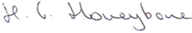
Date: | 27/7/22
Subject Leader: | SRaven
Date: | 27/7/22
Governor: | VHarper-Ward
Date: | 27/7/22

