8.5.25

Dear Parents/Carers

**School meals price increase**

It is with regret that we are having to increase the cost of school meals from £2.80 per day to £2.90 per day (£14.50 per week) with effect from 2.6.25.

This is as a direct result of our catering provider increasing the cost of meals charged to the school. Like many other sectors in the current climate, the costs for the provision of our catering service have increased considerably this financial year and we are unable to absorb the additional costs of the increase as a school.

We understand that this increase may come at a difficult time for some families and would encourage everyone who can to apply for Free School Meals using the link below: <https://www.doncaster.gov.uk/services/schools/free-school-meals>

Meals for children in Foundation and KS1 (Reception and Years 1 and 2) will continue to be provided free under the Government’s Universal Infant Free School Meals scheme. However, if you are eligible for Free School Meals the school receives additional funding to support your child throughout their time at the school. Should you require any help regarding FSM applications, please contact the office.

Many thanks for your understanding with the increase.

Kind regards

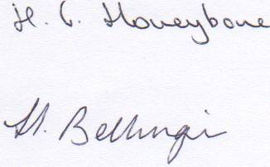

**Helena Honeybone**

**Headteacher**